- Create Database

create database bootcamp;
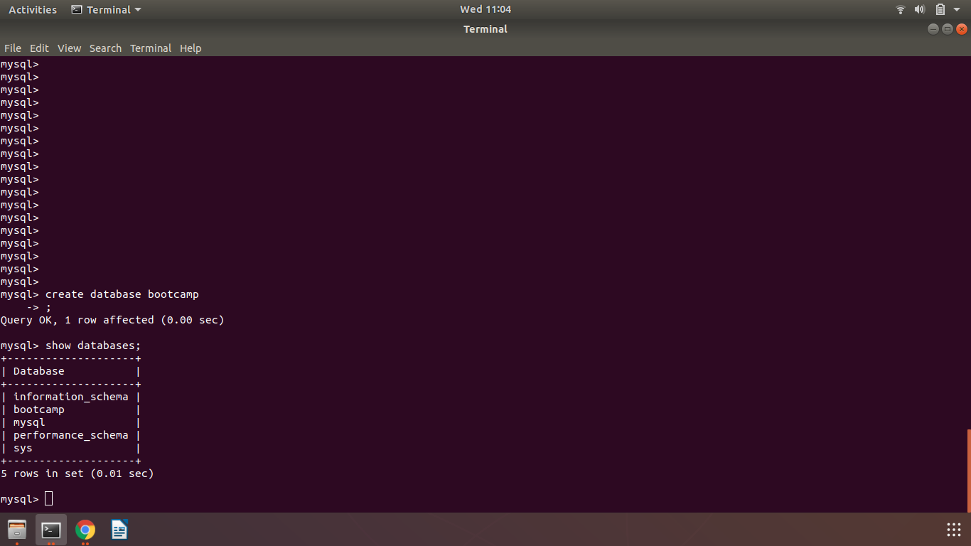

- Design Schema
desc ord;
desc customer;
desc sales;

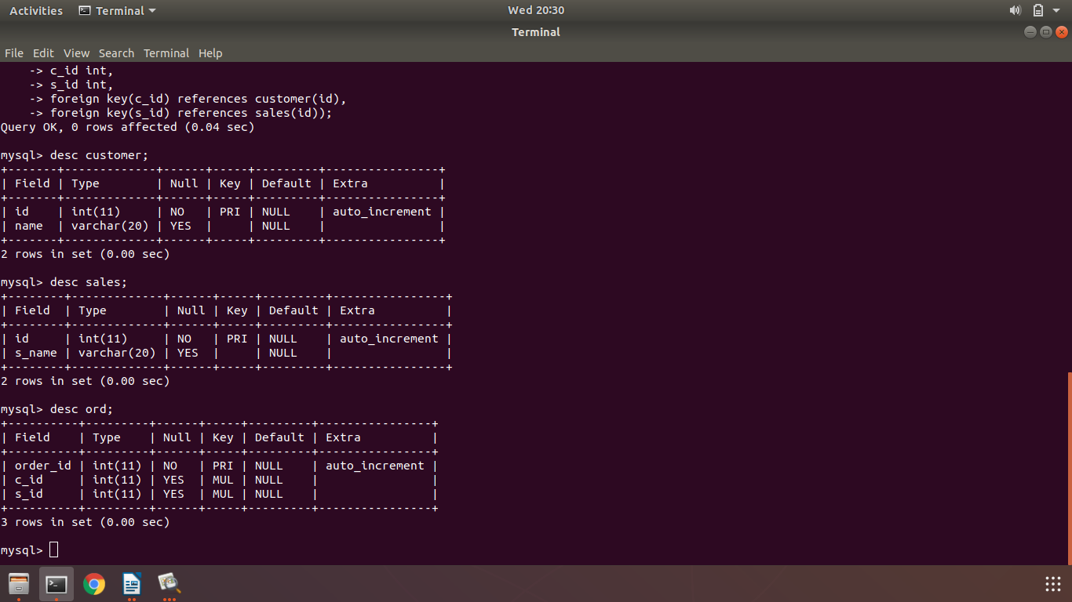

- Create Tables

create table customer(
id int primary key auto_increment,
name varchar(20));

create table sales(
id int primary key auto_increment,
s_name varchar(20));

create table ord(
order_id int primary key auto_increment,
c_id int,
s_id int,
foreign key(c_id) references customer(id),
foreign key(s_id) references sales(id));

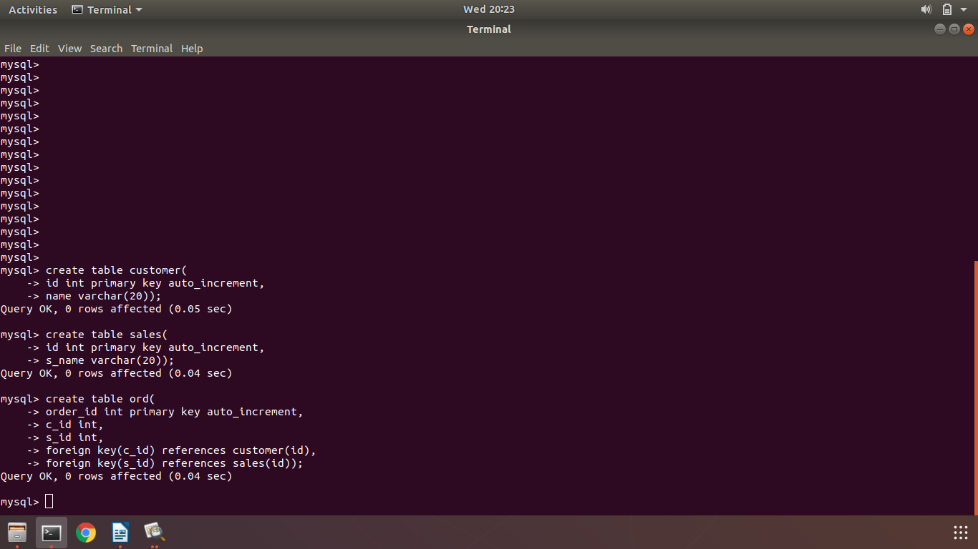

- Insert Sample Data
insert into customer(name) values (‘ABC’),('LMN'),('XYZ'),('PQR');
insert into sales(name) values ('AAA'),('BBB');
insert into ord(c_id,s_id) values (1,2),(2,2),(3,1),(4,1);
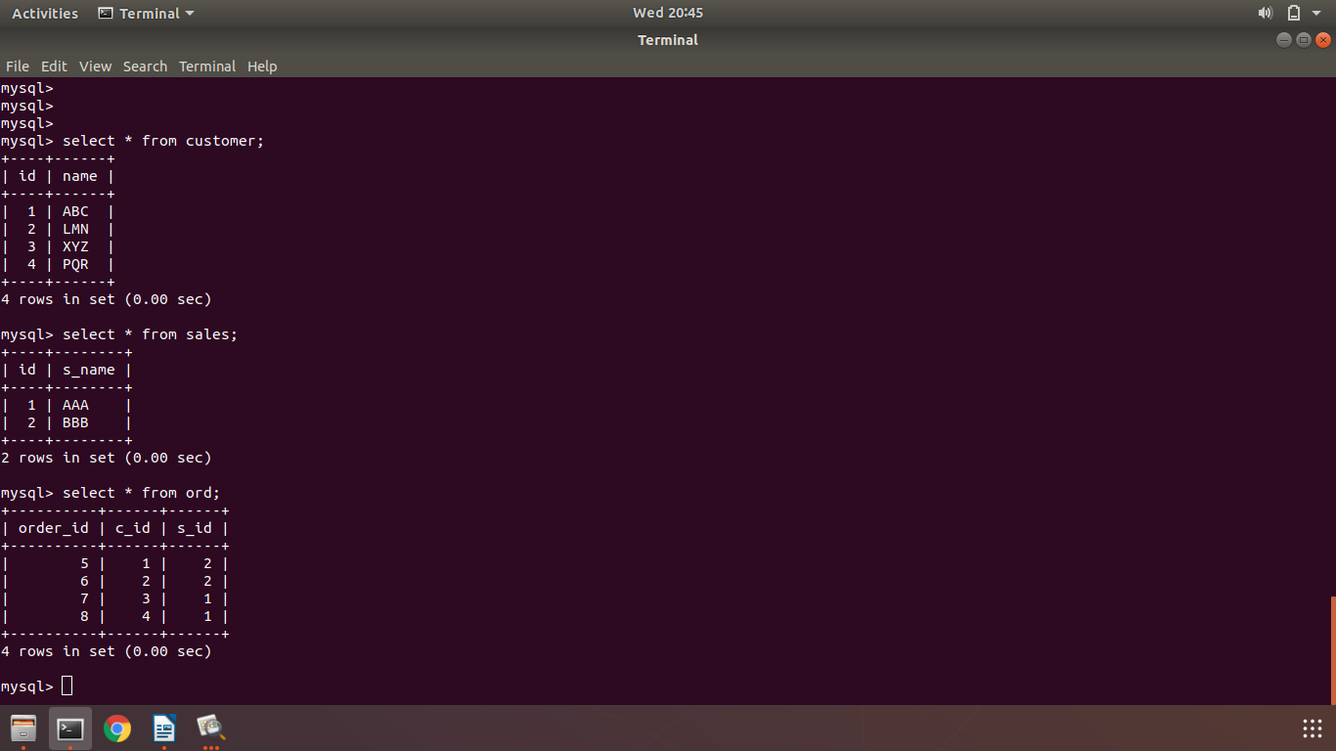

- Find Sales Person having multiple orders

select s.s_name from sales s where (select count(*) from ord o where o.s_id=s.id)>1;

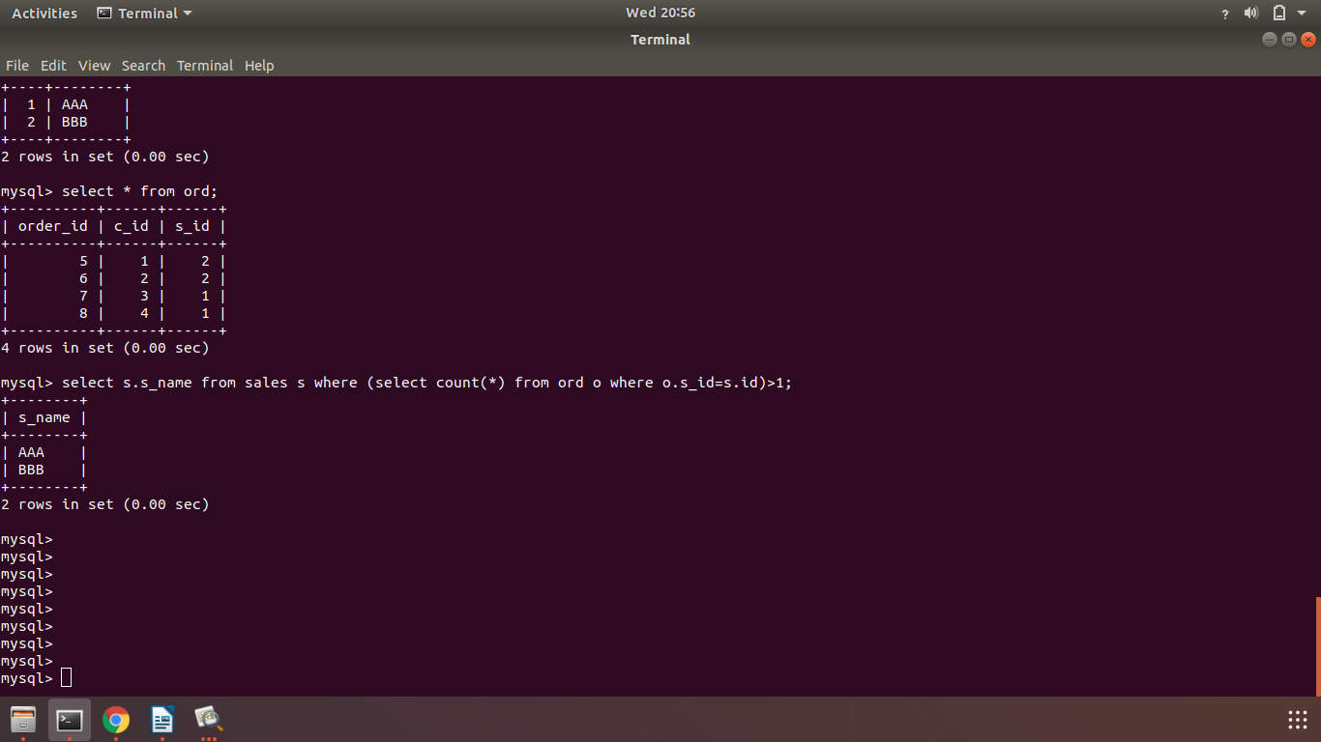

- Find all sales person details with order details

select s.s_name, s.id, o.order_id, o.c_id, o.s_id from sales s, ord o;

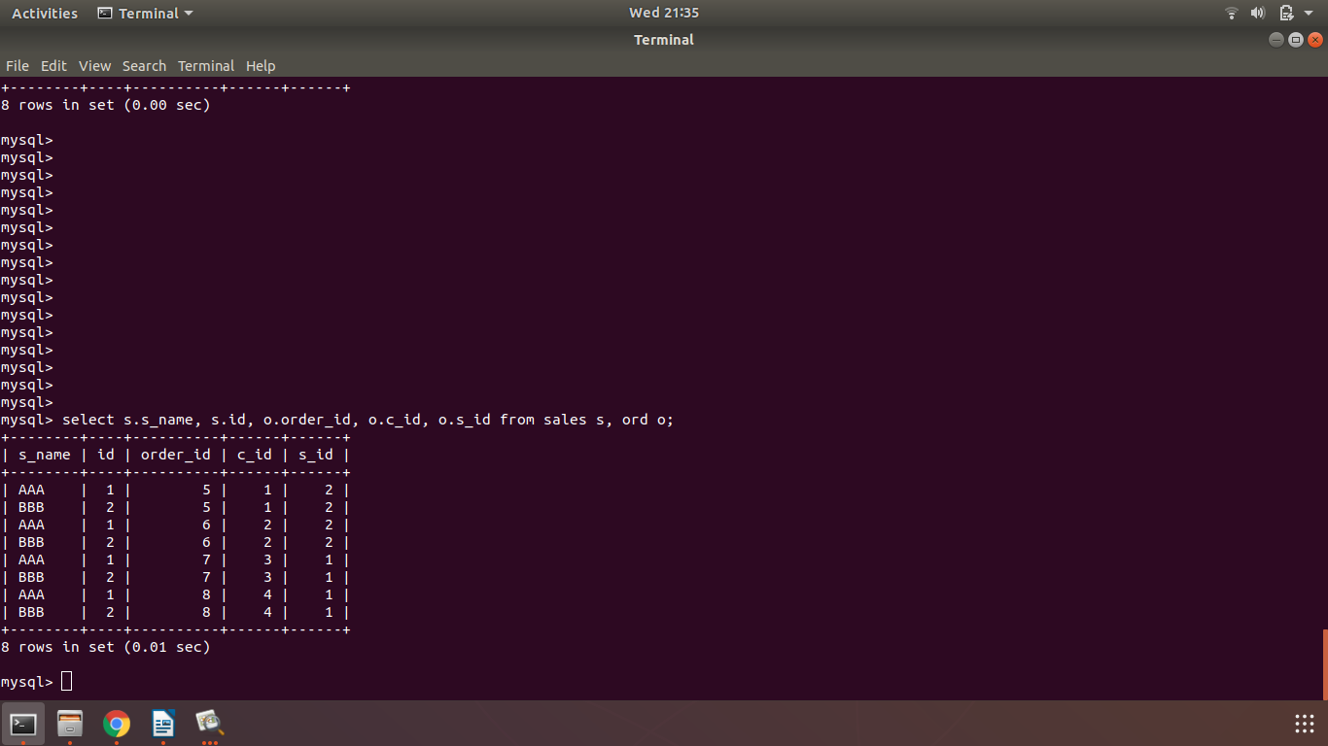
- Create index

create INDEX test on ord (order_id);

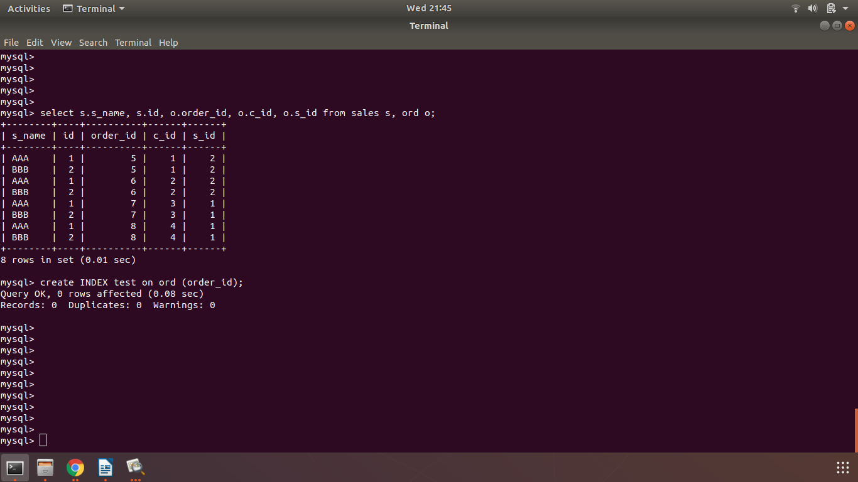

- How to show index on a table

show INDEX FROM ord;

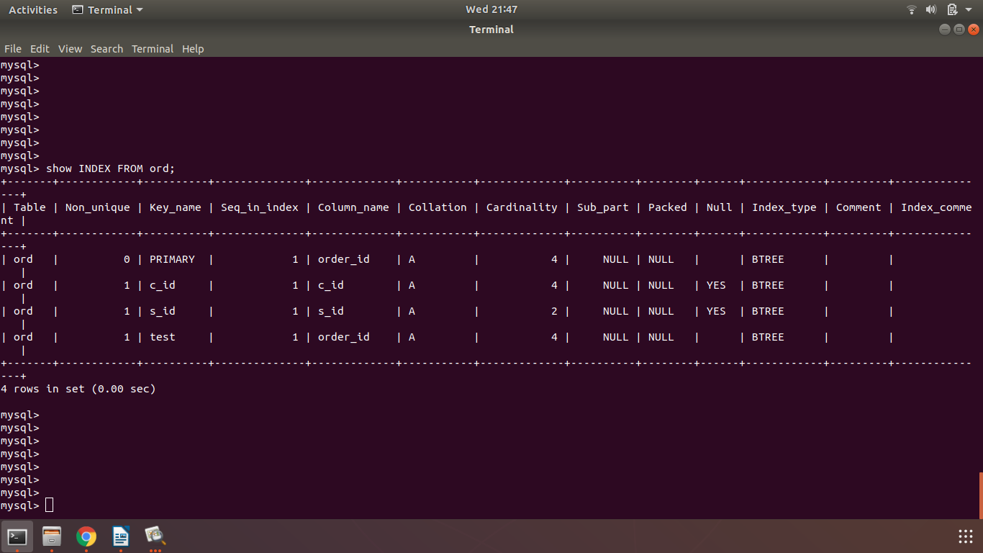

- Find order, salesperson name, user name to whom the order belongs

select o.order_id as Order_Number, s.s_name as Salesperson, c.name as Customer_name from ord o, sales s, customer c where o.s_id=s.id AND o.c_id=c.id;

